aMEI creates captivating aural feasts with Sennheiser Digital 6000
The Queen of Mandopop switches to the new MM 445 capsule

Amsterdam, 12 July 2024 – Her outstanding musical talent and unique voice have gained aMEI worldwide recognition. Since her debut in 1996, she has sold over 50 million records, launching hit after hit in a variety of styles, from moving love songs to energetic rock tunes. Her “ASMR World Tour”, which launched in 2022, has brought a stunning audiovisual feast to millions of fans in cities across Asia, Europe and the USA. As the tour continues in 2024, aMEI has chosen Sennheiser’s MM 445 high-rejection capsule for her Digital 6000 wireless system, providing audiences across the globe with pure and detailed sound at her shows.

For the 2024 leg of her ASMR World Tour, aMEI sings with an SKM 6000 handgeld transmitter coupled with an MM 445 capsule

The ASMR World Tour features visually stunning stage and lighting designs that seamlessly integrate with aMEI’s performance. At the same time, more room is given to the music itself, creating an enveloping sound experience for the audience.

A tour places high demands on the performance of the audio equipment, every detail counts, and choosing the best microphone is an important aspect. aMEI has been a long-time Sennheiser user. From her previous 5000 series analogue microphone system to the current Digital 6000 system, which she adopted five years ago, Sennheiser microphones have accompanied her on one spectacular performance after another.

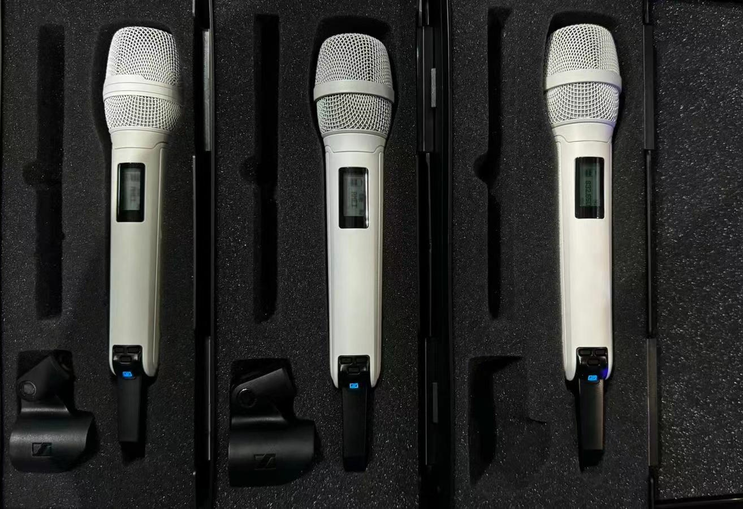 | aMEI has been singing with Digital 6000 since 2019

Until now, aMEI’s capsule of choice was the MD 9235, which the singer used for the “Long Time No See TikTok Summer Concert 2021” and the “ASMR World Tour” in 2022 and 2023. Earlier this year, Chen Qiyao (Yao), aMEI’s trusted monitor engineer for the tour, tested various Sennheiser microphone capsules on the SKM 6000 handheld transmitter, and ultimately decided for an MM 445 capsule.

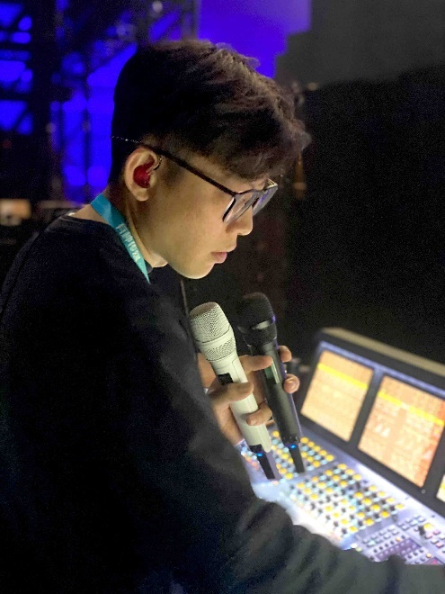 | Monitor engineer Chen Qiyao (Yao) ran various Sennheiser capsules through their paces and decided in favour of the super-cardioid MM 445 high-rejection capsule

Yao shared: “During the trial, aMEI sang just one line with the SKM 6000/MM 445 combo and was instantly amazed by the outstanding performance of the microphone. Her singing is rich in emotion and very delicate, with a strong sense of story. The high sensitivity of the MM 445 perfectly captures and reproduces the emotional changes and rich detail in her voice, making the performance more expressive and appealing.”

Moreover, the MM 445’s high-rejection super-cardioid pickup pattern gives voices greater presence and directness during live performances, resulting in more intense and intimate vocals. The MM 445 ensures maximum protection from feedback in every stage situation and setup. “aMEI listens through floor monitors when she sings, so we needed a microphone with excellent rejection and S/N ratio,” said Yao. “The MM 445 meets our requirements very well and delivers superb linearity. During monitoring, I rarely have to re-adjust the volume. aMEI can hear her own voice consistently and stably, which allows her to concentrate fully on the performance.”

“aMEI sang just one line with the SKM 6000/MM 445 combo and was instantly amazed by the outstanding performance of the microphone.”

In addition to excellent sound quality, Yao also values the reliability and ease of use of the gear. For instance, due to the large number of musicians taking part in the shows, a significant amount of wireless is used on the tour. Frequency planning and management are crucial to ensure smooth operation. The Digital 6000 series features advanced intermodulation-free RF technology, ensuring high-quality audio signals and sound performance, even in harsh RF environments.

Yao concludes, “Live performance is an instantaneous art. Every moment is unique. Therefore, the reliability and excellent sound performance of the microphone are crucial. The digital transmission technology of the D6000 is reassuring, while the high sampling rate makes the sound experience more detailed, making it an excellent partner for singers on tour!”

(Ends)

Also watch this exclusive interview with Yao and Tyler Tan, Sennheiser's Relationship Manager for Asia-Pacific: aMEI's Upgrade: SKM6000 & MM445 added to her Sennheiser Locker! (youtube.com)

The high-resolution images accompanying this media release can be downloaded here.

About the Sennheiser brand
We live and breathe audio. We are driven by the passion to create audio solutions that make a difference. Building the future of audio and bringing remarkable sound experiences to our customers – this is what the Sennheiser brand has represented for more than 75 years. While professional audio solutions such as microphones, meeting solutions, streaming technologies and monitoring systems are part of the business of Sennheiser electronic GmbH & Co. KG, the business with consumer devices such as headphones, soundbars and speech-enhanced hearables is operated by Sonova Holding AG under the license of Sennheiser.

www.sennheiser.com
www.sennheiser-hearing.com

